LinkedIn and Doximity Posts
[IMAGE: INTRO TEXT]
[HEAD]
Speed and precision. Because diagnostic quality matters.
[SUBHEAD]
An industry-leading CT scanner has arrived at <Facility Name>

[BODY COPY]
You and your patients deserve the most advanced CT – Dual Source CT. That’s why we’ve invested in one of the industry’s most trusted CT solutions.
Discover our most advanced CT solution yet
[URL]
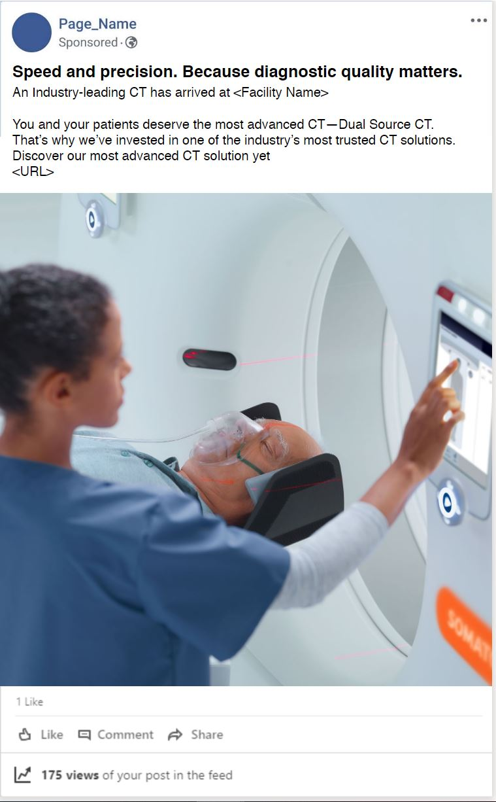
SAMPLE IN LAYOUT

[COPY OVER IMAGE]

[HEAD]
Speed and precision.
Because diagnostic quality matters.
[SUBHEAD]
An industry-leading CT scanner has arrived at <Facility Name>

You and your patients deserve the most advanced CT – Dual Source CT. That’s why we’ve invested in one of the industry’s most trusted CT solutions.
Discover our most advanced CT solution yet
[URL]

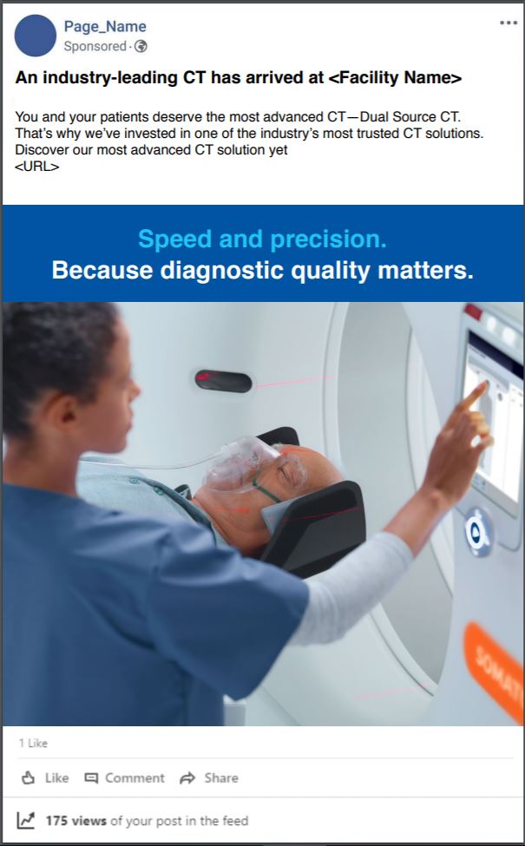
SAMPLE IN LAYOUT

[COPY-ONLY: CTA]
Discover our most advanced CT solution yet
[URL]

