Social Posts
For use on Facebook and Instagram

POST
<Handle> Comfort. Confidence. Your new CT experience. Advanced CT has arrived at <Facility Name>
Get the experience you want. And the answers your doctor needs. Our new, advanced CT scanners deliver both a better patient experience and the precise, hi-res images your physician needs.

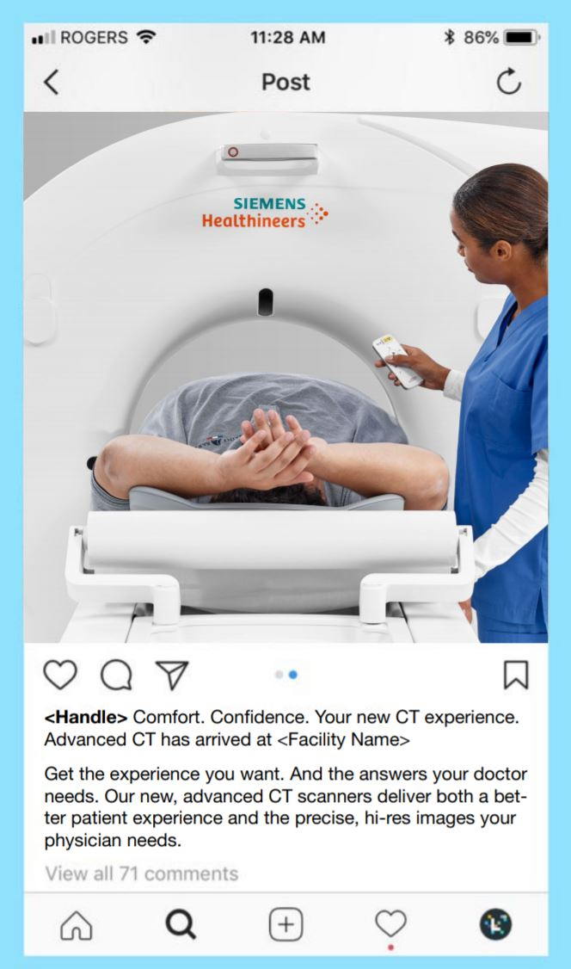
SAMPLE IN LAYOUT

POST
Headline (over image)
Comfort. Confidence.
Your new CT experience.

Body Copy
<Handle> Advanced CT has arrived at <Facility Name>
Get the experience you want. And the answers your doctor needs. Our new, advanced CT scanners deliver both a better patient experience and the precise, hi-res images your physician needs.
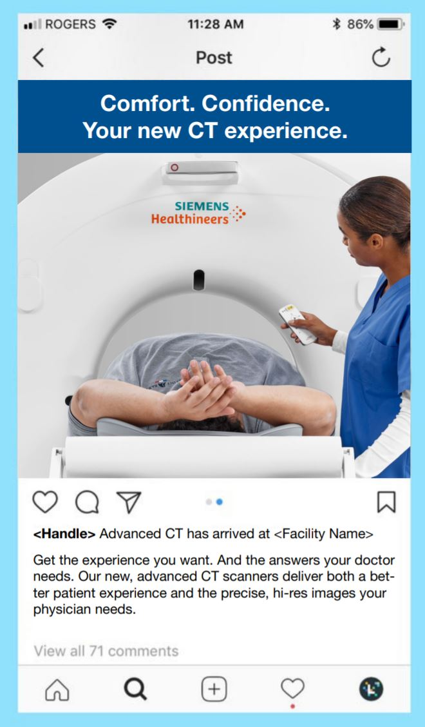
SAMPLE IN LAYOUT

POST
HEADLINE
Patient Comfort. Diagnostic Confidence.
Experience it all in our new CT scanner.
SUBHEAD
Advanced CT has arrived at <Facility Name>
COPY
Welcome to a better CT experience. <URL>
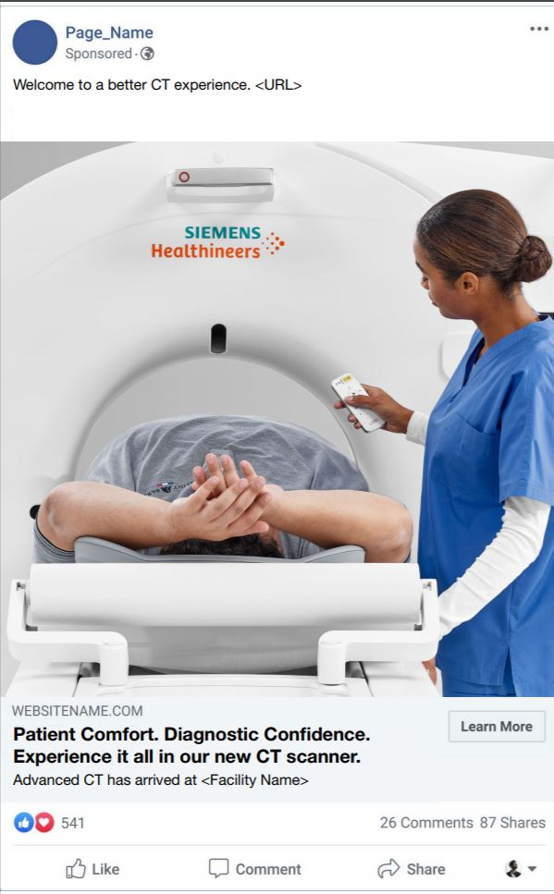
SAMPLE IN LAYOUT

POST
HEADLINE OVER IMAGE
Patient Comfort. Diagnostic Confidence.
Experience it all in our new CT scanner.
SUBHEAD
Advanced CT has arrived at <Facility Name>
COPY
Welcome to a better CT experience. <URL>

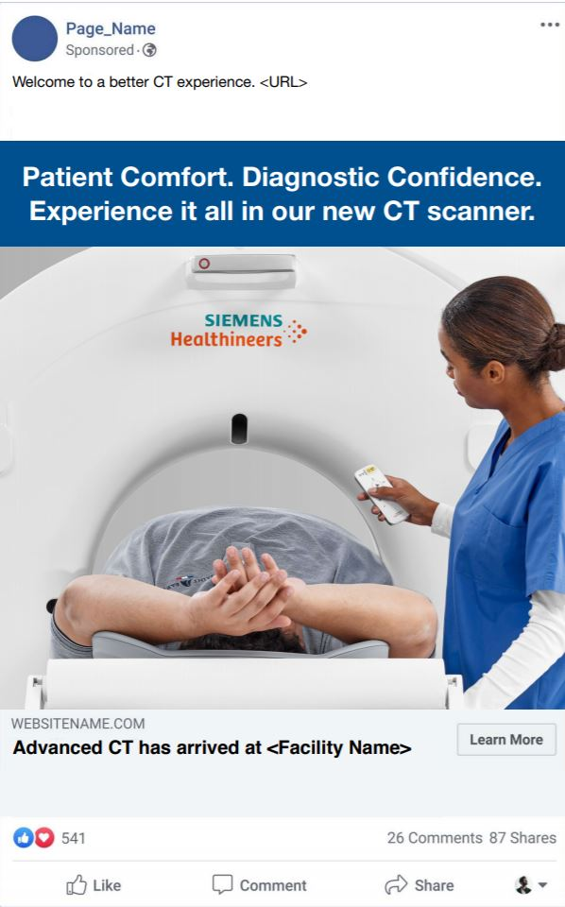
SAMPLE IN LAYOUT

