

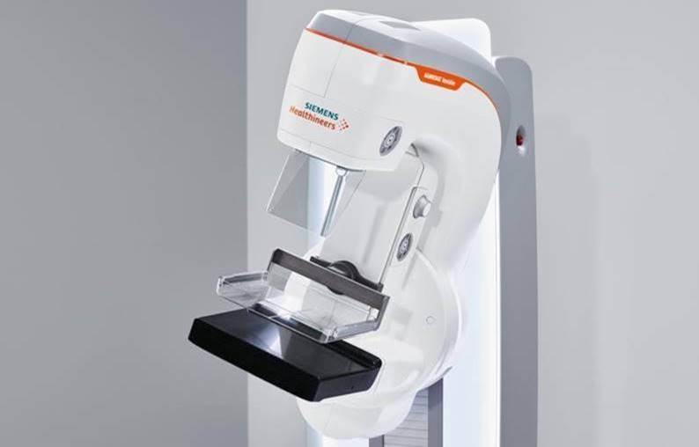

*Not all mammography systems are alike.*

Meet our new difference maker.

Hello <Name>,

At <Facility Name>, we know that seeing the difference in every mammography scan is the key to making a difference in every woman’s life. That’s why we invested in the **MAMMOMAT Revelation** – to detect breast cancer early, when it is at its most treatable stages.

**Innovative wide-angle technology**

The industry’s widest 50o image acquisition angle delivers up to 3.5 times higher depth resolution* than a narrow-angled system for better separation of overlapping tissue. When you see more, you have a good chance to find cancer earlier.

**Personalized compression for a more comfortable mammogram**

Pain and discomfort are top reasons why women skip mammograms. Our compression is tailored to the structure of each woman’s breast, so we can deliver a better patient experience.

**Instant breast density risk assessment**

We can measure breast density right at the workstation and assess her risk before she leaves the exam.

*Call us to learn about the mammography system that’s making the difference in our patients’ lives.*

Facility Name at <XXX-XXX-XXXX> or

<Email@address.com>

<Street Address>

<City, State, Zip>

*Maldera et al. (2016): Digital breast tomosynthesis: Dose and image quality assessment. Physica Medica, pp. 1-12.