



**Finally,**

**mammograms that aren’t such a pain.**

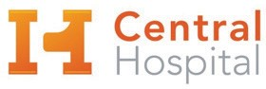

**Introducing the mammogram that’s easier   
on you.**

MAMMOMAT Revelation personalizes compression, reducing the force for a more comfortable exam.

**More Comfort**

**Greater Accuracy**

**Fewer False Alarms**

**Lower Dose**

Anne Goodman 123 Central Street

Anytown, USA 01100

**Get comfortable**

**at Central Hospital.**

**Make your appointment today!**