

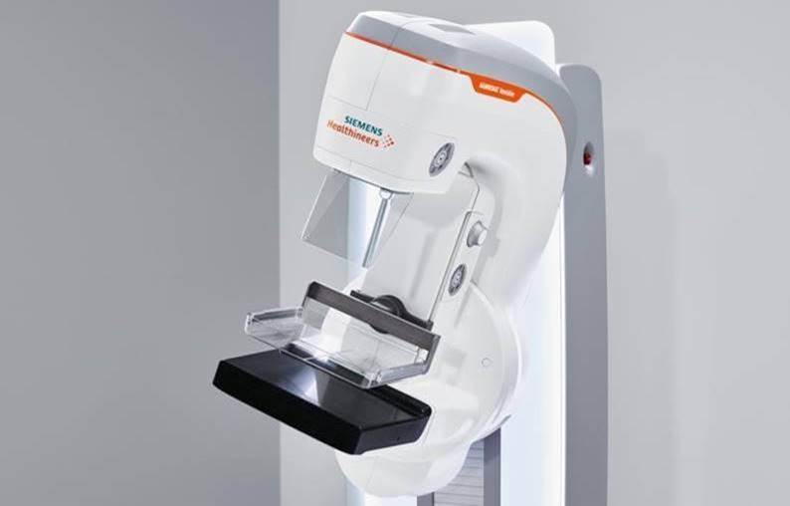

Finally, a mammogram that’s not such a pain!

Hello <Name>,

Why must mammograms be so painful?

At <Facility Name>, we know discomfort is the top reason why women avoid mammograms. So, we did something about it – we bought a mammography machine that’s built to be different. Meet our new **MAMMOMAT Revelation**, the system that may change the way you see breast health.

**Personal compression for a comfortable exam**

Compression is necessary for an accurate test. But it can be painful. We make comfort personal. Our machine recognizes that each breast is different, and it automatically compresses your breast based on breast structure. And our paddles have soft edges shaped to your breast, so comfort is there from the start!

**A 3D mammogram for a confident diagnosis**

This is a 3D mammogram that produces high-quality images, making it easier for us to find cancer* with confidence. With high definition tomosynthesis, we can see details that might otherwise be hidden.

*Are you ready for a mammogram that’s not such a pain? Call us for an appointment.*

<XXX-XXX-XXXX>

<Email@address.com>

<Street Address>

<City, State, Zip>

*Compared to FFDM