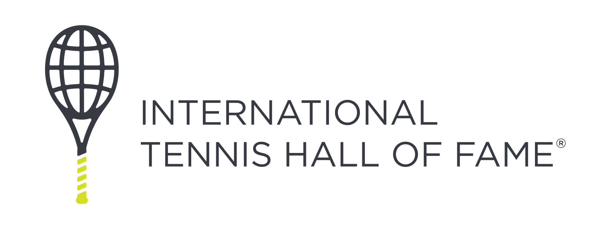
Position Description
Title: TeamFAME Program Staff Department: TmFAME
Hourly Rate: $25.00

Position Overview
TeamFAME Program Staff play a critical dual role in supporting students both on the court as tennis mentors and off the court as positive role models and facilitators of enrichment activities. Program staff help create a safe, inclusive, and inspiring environment where every participant feels valued, challenged, and supported to grow.

This is an ideal position for individuals passionate about sports-based youth development, coaching, education, and/or community service.

Key Responsibilities
On the Court:

- Assist with the delivery of tennis and fitness programming for beginner and intermediate players, including off site tennis instruction at partner sites.
- Support lead coaches by organizing equipment, setting up drills, and modeling good sportsmanship.
- Coordinate and support all 10 and under tennis outreach initiatives.
- Foster a fun, positive, and respectful environment for learning and play.
- Motivate and encourage every student to try their best, stay engaged, and improve every day—regardless of whether they’ve played tennis before or are new to the sport.

Off the Court:

- Facilitate enrichment activities focused on social-emotional learning, teambuilding, goal setting, life skills, and TeamFAME values (e.g. courage, respect, sportsmanship, perseverance)
- Build strong relationships with students based on trust, consistency, and care.
- Support daily operations and routines such as snack time, attendance, transitions, and behavior management.
- Drive the TeamFAME van or ride along as the safety monitor to transport students to and from programming.
- Assist as needed with academic work and executive function skills. Encourage the importance of academics to encourage a positive mindset around school.
- Promote a sense of community among students and reinforce positive expectations.
- Participate in both voluntary and assigned Professional Development opportunities to enhance the program content and practices.

Requirements & Preferred Skills
- 2+ years of experience working with youth in coaching, mentoring, teaching, or camp settings preferred.
- Currently pursuing or holding a degree in Education, Secondary Education, Counseling, Psychology, Social Work, Sports Management, or related field.
- Familiarity with tennis, fitness, or sports instruction.
- Experience facilitating enrichment activities (e.g., leadership, life skills, teambuilding games, social-emotional learning).
- Interest in sports-based youth development and/or tennis; playing experience is a plus but not required.
- Ability to connect and build relationships with kids of all ages from diverse backgrounds and apply knowledge from trauma-informed trainings.
- Energetic, dependable and team-oriented and strong communication skills.
- Ability to pass background check and complete necessary training.
- Bilingual skills a plus, Spanish and Portuguese preferred.

Location & Time Commitment
- This position is full-time and in-person position, located at the International Tennis Hall of Fame in Newport, Rhode Island
- Full-Time, must commit to scheduled program hours.
- Afterschool program Hours: Tuesday – Friday, 2PM to 6PM (Fall, Winter, Spring)
- Summer Program Hours: Monday – Thursday, 8AM to 5PM (end June – August)
- Flexible scheduling options available depending on availability and program needs.
- Must be available for special events as needed, which will include weekends and some extended weekday hours.

About TeamFAME
TeamFAME is the flagship youth development program of the International Tennis Hall of Fame (ITHF). We use tennis as a tool to inspire, educate, and empower youth—particularly middle school students from underrepresented communities in Newport County. Through year-round programming that combines sport, academic enrichment, and character development, we help student-athletes build confidence, purpose, and a sense of belonging.

About the International Tennis Hall of Fame

Our Mission
The International Tennis Hall of Fame preserves and promotes the history of tennis and celebrates its champions, thereby serving as a vital partner in the growth of tennis globally.
The ITHF is a non-profit organization located in Newport, Rhode Island. It is a dynamic organization comprised of diverse business operations to support that overall mission.
- The Museum at the ITHF chronicles the history of tennis and the stories of its greatest champions through an extraordinary collection and interactive exhibits.
- The Hall of Fame Tennis Club is a year-round tennis facility offering junior and adult programming on three surfaces – grass, hard courts, and clay.
- Annually, the Hall of Fame hosts the Hall of Fame Tennis Championships.
- Host the Hall of Fame Induction Weekend when the highest honor in tennis is presented to the sport’s greatest champions.
- As a non-profit organization, the ITHF is active in development outreach and philanthropic programs.
- The ITHF is an engaged partner in the global tennis industry and is committed to celebrating the sport’s greatest champions and promoting tennis history through strategic programming around the world.

Hall of Fame Open
Scheduled for July 6-13, 2025, at the International Tennis Hall of Fame, the Hall of Fame Open will become just the second combined ATP and WTA 125 level event in the United States. It will be the only grass court stop on the Hologic WTA Tour outside of Europe, and the first women’s professional tournament at the ITHF since the Virginia Slims of Newport concluded in 1990. Equal prize money will be awarded to both the men’s and women’s draws.
Induction Celebration
The Class of 2025 will be officially inducted into the International Tennis Hall of Fame during the Induction Celebration in Newport, Rhode Island, from August 21-23, 2025. The 2025 Induction Celebration will usher in a new era for the Hall of Fame that highlights the best of tennis culture through art, fashion, music and more.
During the weekend, the Hall of Fame Celebrity Pro Classic charitable tournament will feature two teams consisting of Hall of Famers, celebrities and creators, all mic’d up as they take the court together through six matches of fast-paced mixed doubles play.
Attendees can enjoy Fanfest activities, meet and greets, and live podcast recordings, along with premium New England faire from food trucks across the region. The ITHF will also return its Courting Fashion event to celebrate iconic tennis fashion on display at the historic mansion Marble House and will close out the weekend with its formal induction ceremony of the 2025 Class, followed by a live musical concert.

Application Process
Resumes with a cover letter should be submitted to: hradmin@tennisfame.com

